Readspeaker in TCU Online
Take advantage of the ReadSpeaker Suite of Learning Tools to enhance your understanding and comprehension of the materials posted.
In Content, when you click on the Listen Button, the text is highlighted and read for you. Listening to text read aloud is shown to improve your reading comprehension. You can change the reading speed, the text highlighting, download the mp3 file, hover over the text you want to be read, enlarge the text, create a simple view of the text, use a page mask, translate, look up a word, and more. Many of these tools can aid distracted readers to stay on track. The help file has information that can aid students who are using ReadSpeaker webReader with a screen reader.
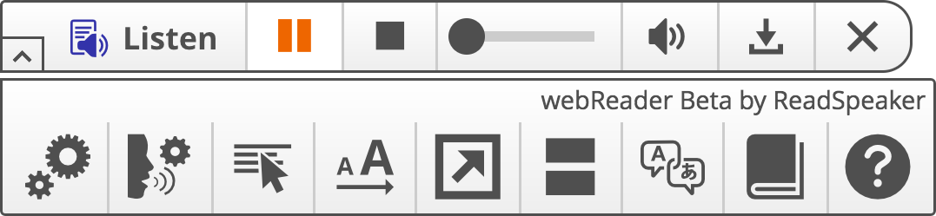
Microsoft Office product files and PDFs can be opened in Content by using the ReadSpeaker docReader. To open your document in ReadSpeaker docReader, click the document, and then click on the Open in docReader button at the bottom of the page.

To read the other areas of TCU Online, you will need to use ReadSpeaker TextAid. All users must first access TextAid from within TCU Online. The link to TextAid is found by first selecting a course in TCU Online you are enrolled into, then click the More Tools menu on the nav bar, then select TextAid. After agreeing to the terms and conditions, your account is created. Accessing TextAid from TCU Online will launch the ReadSpeaker TextAid application that displays in a full browser window.

For more information about the ReadSpeaker tools, see the support page ( https://tcuonline.tcu.edu/how-to-hub/instructor-how-to-hub-for-tcu-online/integrations-and-mobile/readspeaker/)

