Submitting Your Video Assignment for Grading

- Go to the Activities menu, and click on Assignments.
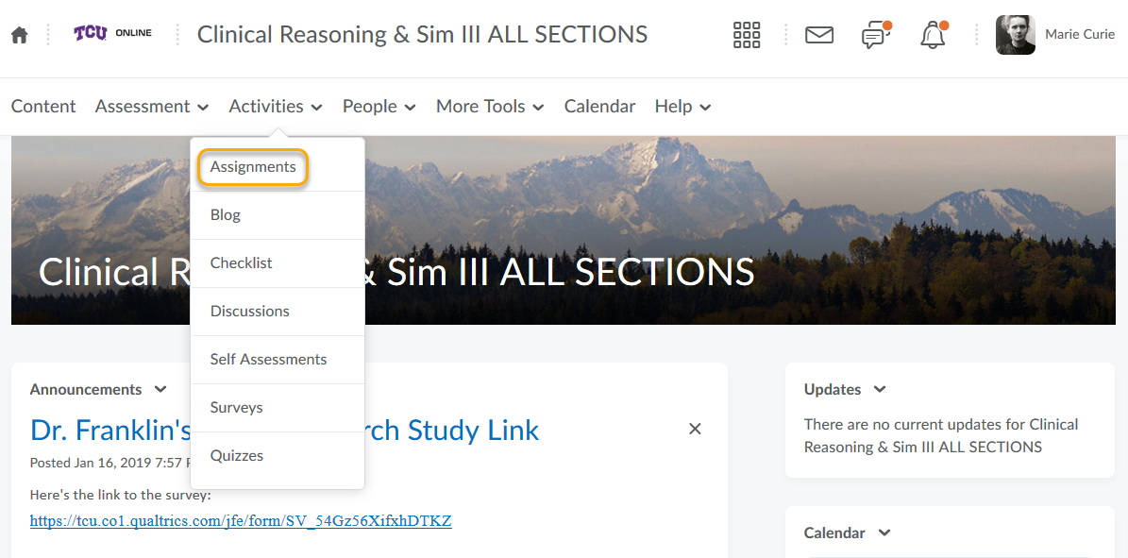

- Click on the Assignment Folder you want to submit your video to.
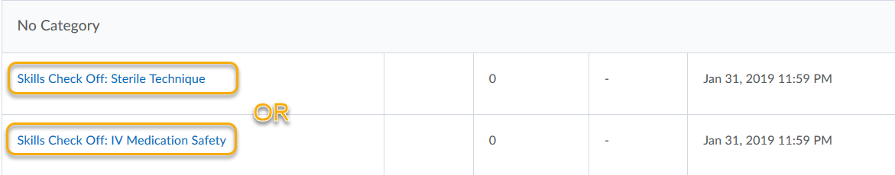

- Click on the Insert Stuff button.
- Click on the Panopto link.

- Use the drop-down to find the Panopto Submission folder for your class.
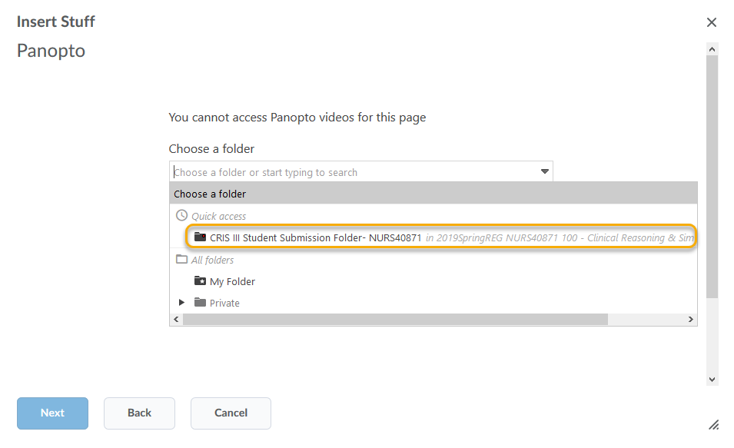

- Find your video, and click on the Radio button next to it.
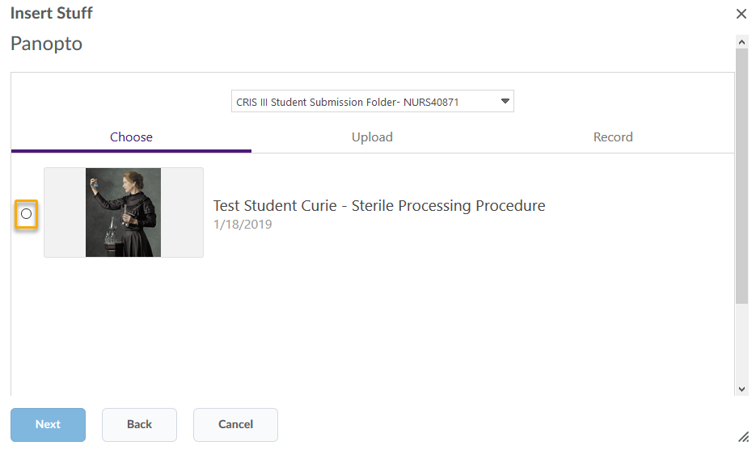

- Scroll down and click on the purple Insert button.
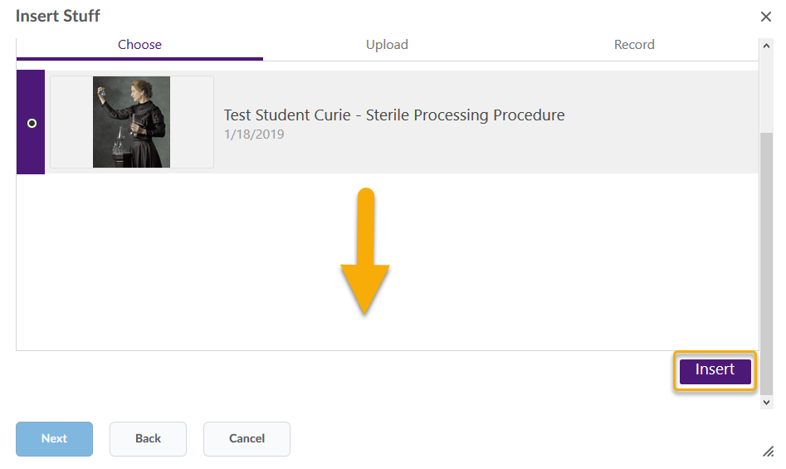

- Click on the blue Insert button.
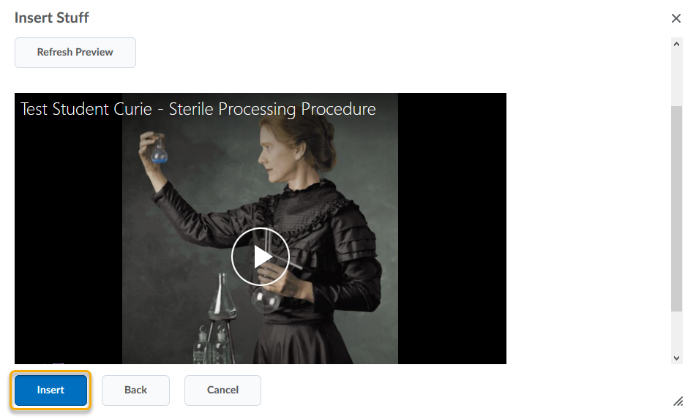

- Click on the Submit button.
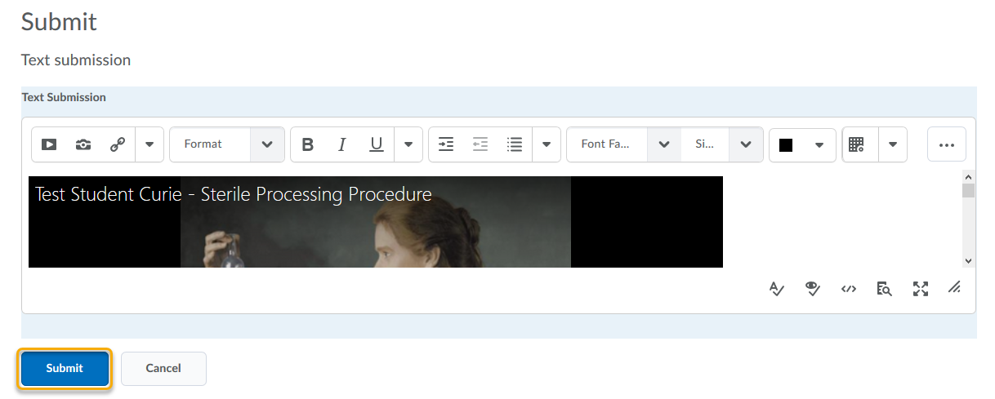

- You will receive an email confirming your submission.
