Logging in Using the Mobile App
It is recommended that you are connected to wifi when attempting to upload or record your videos.
- Record a video using your mobile device’s build in video recording app.
- Download the Panopto App from the Appstore or Google Play Store.
- Once you open the app click/tap on the ”Enter Site URL” or “Enter URL” option located in the top right corner.
Android | iOS
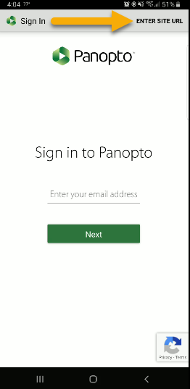 | 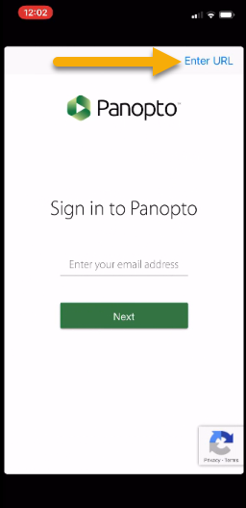

- When prompted enter tcu.hosted.panopto.com in the address box. Press return or next to continue.
Android | iOS
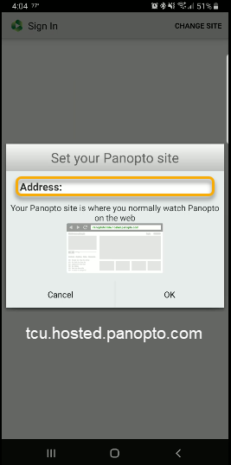 | 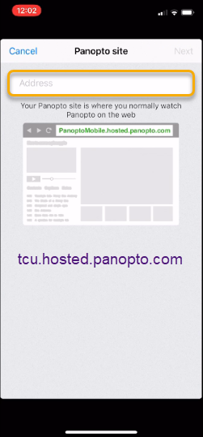

- Enter your TCU credentials and then click/tap the Sign In button.
Android | iOS
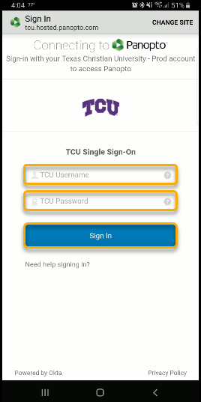 | 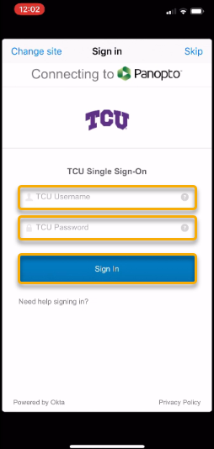

Uploading on a Android device
- Click/Tap on the Cloud icon.
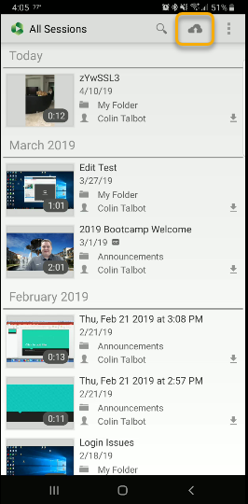

- Use the folder drop-down to find your class submission folder.

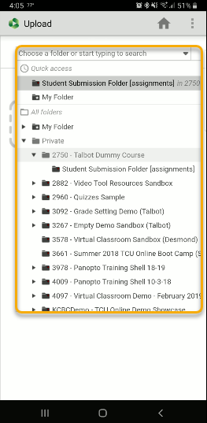

- Click/Tap in the “Choose video or audio files” area to search for your recorded video. Once selected the upload will start automatically.
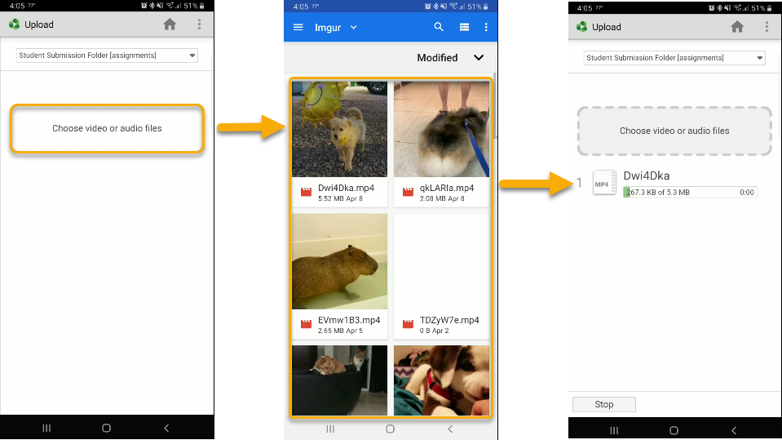

- Make sure that all of your files have uploaded successfully before closing the app.
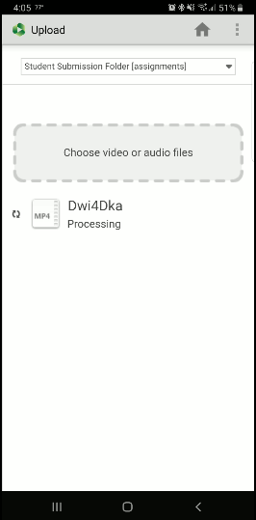

Recording and Uploading on iOS
- Click on the Menu in the upper left corner.
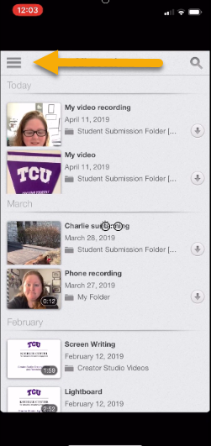
- Then click on the Record and Upload button.
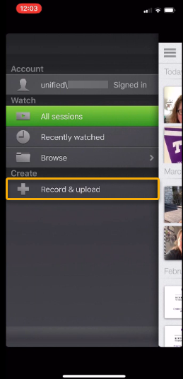

- Choose a Folder to record or upload a video to. If it does not appear on the initial list click on the Browse button to search all folders.
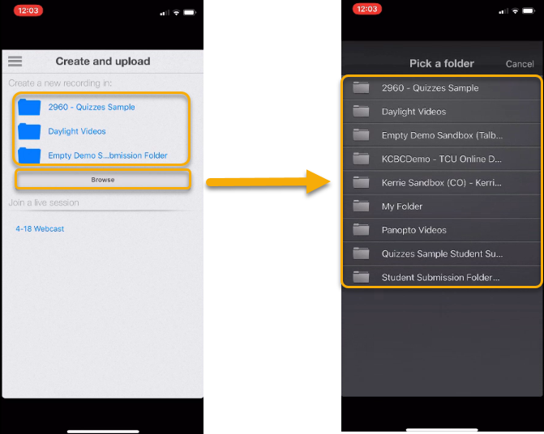

- To use a video you have already recorded click on the Choose a Video button.
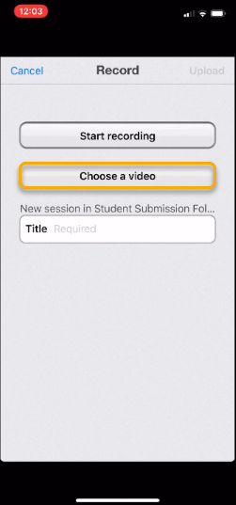
- Select the video file you want to upload. Verify that it is the correct video and click the Choose option.
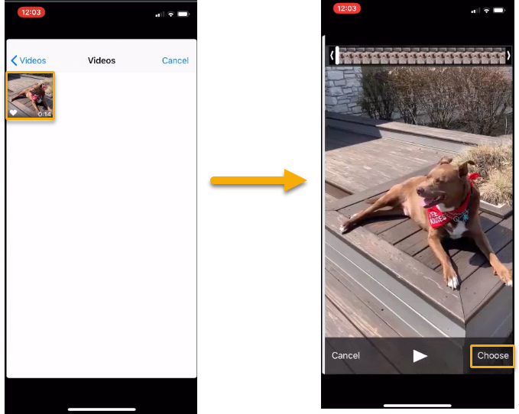
- Enter a Title and press the Upload button.
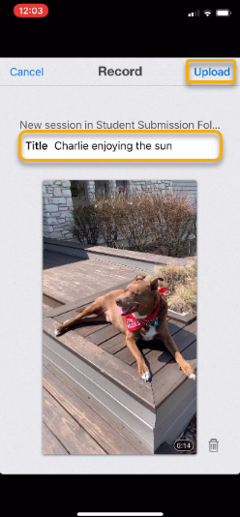
- To Record a New Video, select Start Recording. You may be prompted to give the Panopto app access to your camera, microphone, and file storage locations.
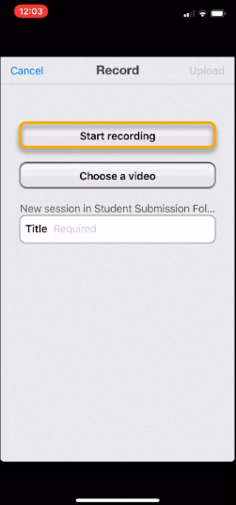
- Record your video.
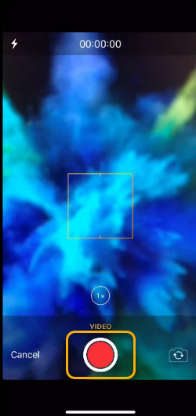
- When you are finished recording, review your video, and then click the Use Video button to upload..
- Enter a Title and press the Upload button.
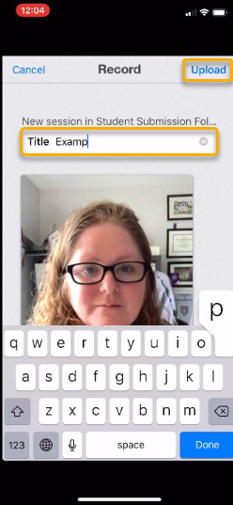

- Make sure that all of your files have uploaded successfully before closing the app.
